Abhinav Jain

500083840

Experiment-2

AIM:-

Working with Docker (Basic Commands

Steps to Complete:

* Search a Redis image on DockerHub

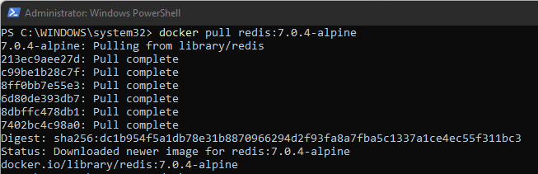

* Run Docker Container of Redis Image in background

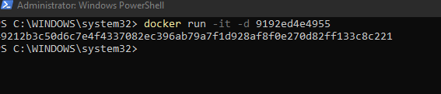

* Run Docker PS and Docker PS–a

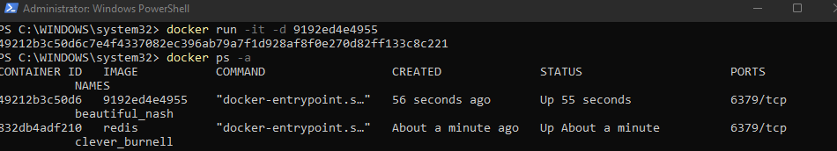

* Run Docker Container and take its console



* Create a Docker Volume and connect it

